Task 3a – Gathering Feedback

Plan for Feedback
- What methods are you using?
- For each method describe the following;
  - Why are you using that method? (Think about benefits)
  - Which audience is it for?
  - How will you tailor it for that particular audience?
  - How exactly will this method be delivered and recorded? Walk them through step by step
Methods of Use
- Questionnaires - Non-Technical Audience
- Observations - Non-Technical Audience
- c – Technical Audience
Feedback Sheets and Resources
- Copies of all Feedback sheets and Questionnaires with links to any online version if necessary
- Need a copy of the questionnaire with a link to the Microsoft forms apge or google forms page if needed
- Need a copy of the observation recording sheet along with the scenarios being observed
- Need a copy of the paired coding review sheet for comments for recording comments
Summary of Findings
- Here you must go through each method and summarise breifly what your findings were
- You must also mention how effective the method was in getting good feedback for your prototype and if it was suitable for target audience
- Here you just say what you found not the impact or how you would change it
- So, for example, you would mention, “I found that my website is not easy to use as in the observations all scenarios took 5 seconds longer than they should have with testers pointing to confusion as to where to go as the main reason”. You don’t say why this is, or how it could be improved, this is for the evaluation.
- Include some graphs if you can and a mix of qualitative and quantitative data.

MAKE SURE YOUR NAME IS IN THE HEADER OR FOOTER ALONG WITH PAGE NUMBERS AND YOUR CANDIDATE NUMBER AND SAVE THE FILE CORRECTLY

Feedback Method

To gather useful qualitative and quantitative feedback on the Greenfield Local Hub digital solution, I will have to use effective methods. Therefore, I chose to use structured questionnaire forms to collect all the feedback that will help improving the prototype in the future. The online forms I will create, will be targeting two different audiences, technical users that understand development language and terminology, and non-technical users that are ordinary people that could potentially use the product.

Questionnaires, Non-Technical Audience
Method of Use:
- I will be using an online form to gather feedback from non-technical users after they have used the digital solution I have created, Greenfield Local Hub web application. This method will be useful to gather qualitative and quantitative data that can give me a better understanding on what majority of users think and look for on the solution. I will tailor the feedback form to the non-technical users by using non-technical terminology that any person could understand and answer.

How the method will be delivered and recorded:
- Questionnaire will be created using Microsoft Forms
- The forms link will be sent to selected non-technical users via email
- In the email it will explain to the user that they should use the system for 10 minutes and then complete the form via the link in the email
- All responses will be collected automatically and anonymously
- Finally, all responses will be analysed and displayed in graphs, charts and open comments.

Observations, Non-Technical Audience
Method of Use:
- Feedback will be gathered from non-technical users using an online form. They will have to execute 5 specific scenarios using the digital solution and then fill out the form.

How the method will be delivered and recorded:
- Observed scenario testing will be performed using Microsoft Forms
- The forms link will be sent to selected non-technical users via email
- In the email and form it will explain to the user the 5 scenarios they must try to complete, after they will fill out the form via the link in the email
- All responses will be collected automatically and anonymously
- Finally, all responses will be analysed and displayed in graphs, charts and open comments.

Paired Coding Reviews, Technical Audience
Method of Use:
- Technical users will have two monitor screens, displaying the programs code and the working web application on each screen. While they test and look through the digital solution, I will ask the technical user questions from an online form I created. I will fill out the form based on their experience and they will try find any areas of improvement. The online form will use technical language that only technically qualified individuals will be able to answer. This method will be used so that I can tackle all parts of program together with a technical user like me, the online form will be covering all parts of the code and program as well.

How the method will be delivered and recorded:
- Online form will be created using Microsoft Forms
- A technical peer will be selected
- A live review meeting will be arranged (Zoom, Teams, Discord or in person)
- Tackle all sections of the program (Views, Models, Controllers, SeedData.cs, etc.)
- Feedback will be given from the reviewer and recorded in the online form
- Lastly, all review points will be summarised and noted

Summary of Findings

  - Questionnaires, Non-Technical Audience

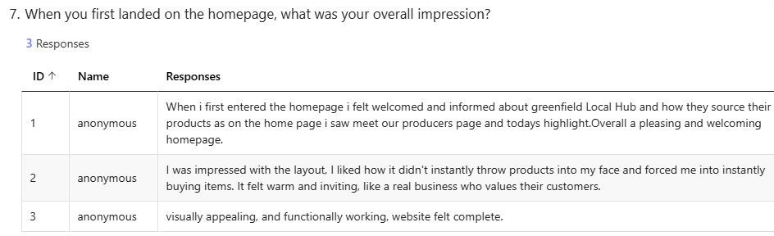
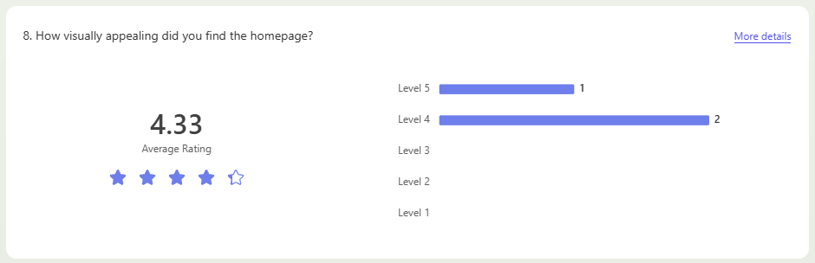

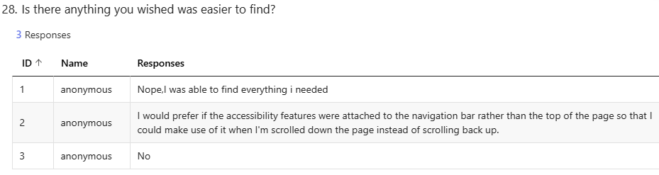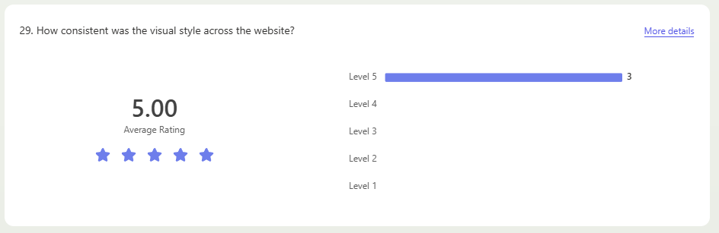
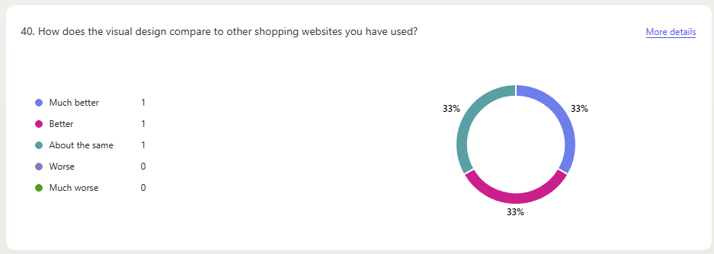
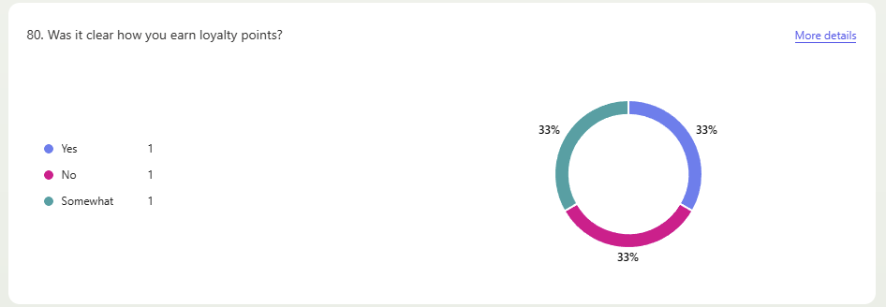
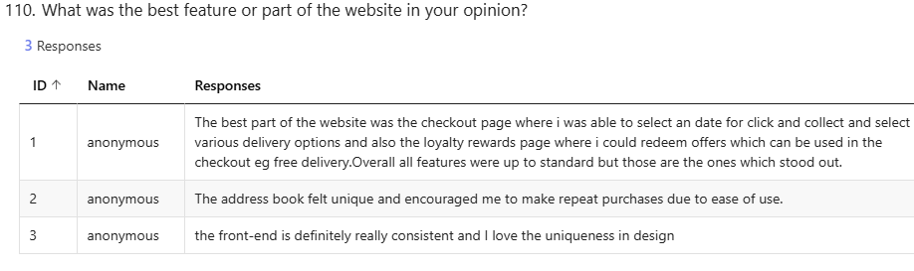
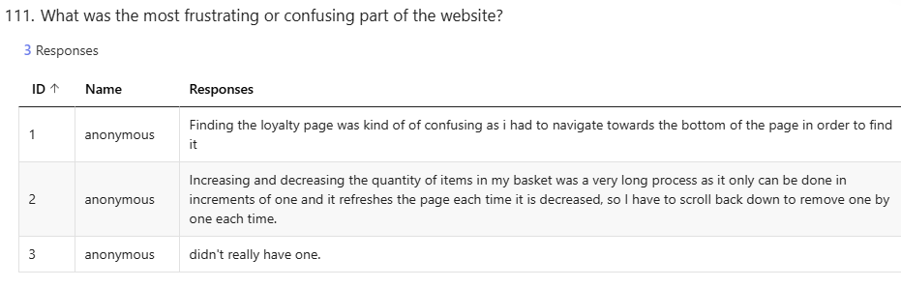
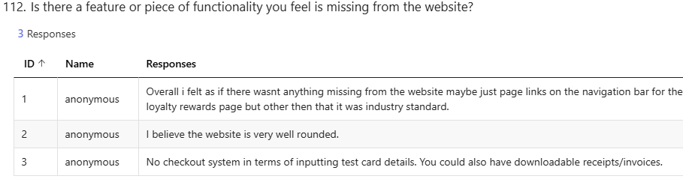
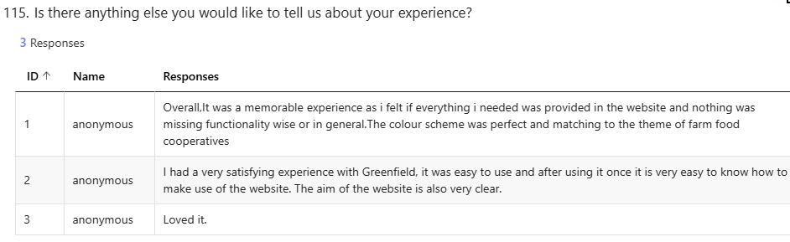
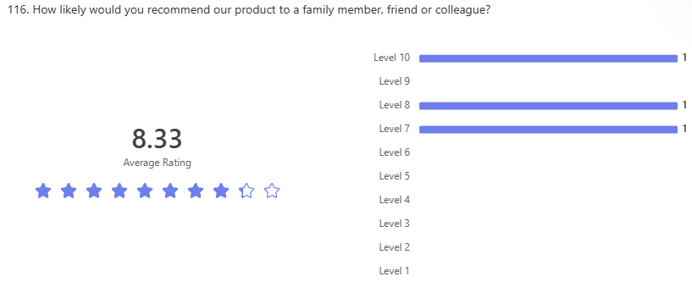

  - Paired Coding Reviews, Technical Audience
